Welcome to Health and Home & Careers
Mrs. Cortese (Breheny)
ecortese@oriskanycsd.org
315-768-2063
Student Council Advisor
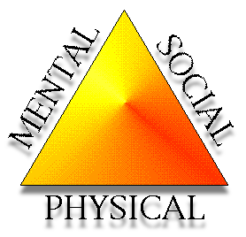
Students Against Destructive Decisions (SADD) Advisor
HEALTH 7
Intro. to Health
Decision Making
Peer Pressure
Bullying
Tobacco
Alcohol
Drugs
Family Life
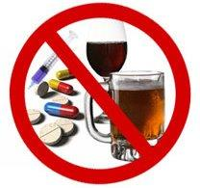
HEALTH SKILLS:
Self/Relationship Management Stress Management
Communication Advocacy
Decision Making Goal Setting

H.S. HEALTH
Intro to Health
Nutrition
Mental Health
Alcohol and Tobacco
Drugs
Parenting
Family Life
First Aid and CPR
HOME & CAREERS 8th
Child Care Development
Clothing and Textiles
Sewing Machine Basics
Career Exploration
Career Planning
Consumerism

HOME & CAREERS 7TH
Personality
Kitchen Equipment
Recipe Use
Meal Planning
Table Setting / Etiquette
Food Lab Experience

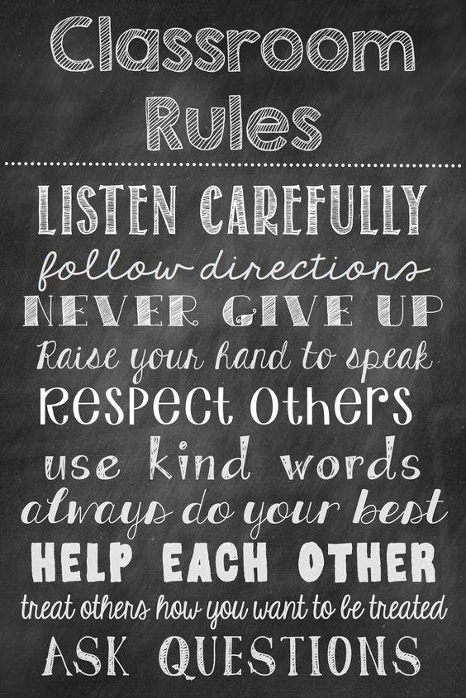
NEEDED SUPPIES:
- 1 inch Binder
- Take Home Folder
- Loose Leaf Paper
- Pen or Pencil
(All classes except H&C7)
GRADING POLICY:
Formative: Homework, Bell-ringers,
In-class Activities = 25%
Summative: Tests, Quizzes, Projects, Food Labs = 75%

A Note to Students and Parents:
Please remember that H&C7 is a 10 week course and Health and H&C8 are 20 week courses and it is important that you do not get behind in your work. Please see me with any problems or concerns! Should you have any questions about any of the above information please feel free to contact me at any time.
I look forward to our 20 weeks together!!
Mrs. Cortese

Parents and Students: Please sign below to acknowledge that you have reviewed all the above information. Thank You!!

________________________ _______________________
Student Signature Parent or Guardian Signature

